HINDI DIWAS CELEBRATION ON 19-09-2019 GUEST DR MEENAKASHI PATIL
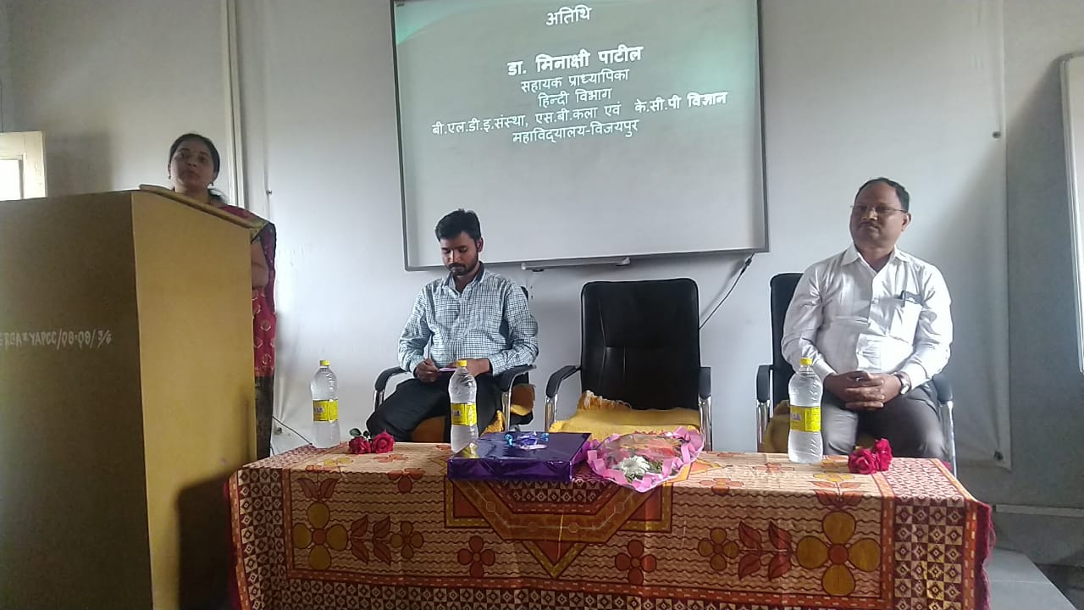

GST ONE DAY WORKSHOP ON 30-09-2019 GUEST SRI KUMARASWAMY I HIREMATH
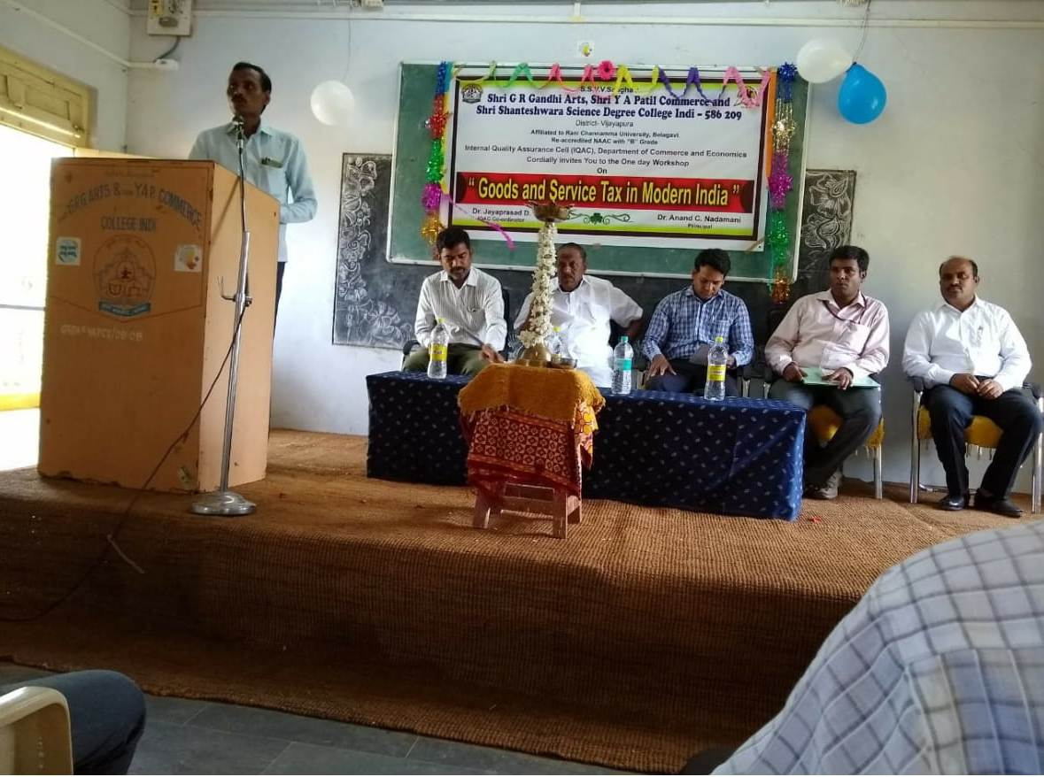

ELECTORAL LITERACY CLUB ORGANISED AWARENESS PROGRAMME ON 25-09-2019 GUEST CHIDANAND GURUSWAMY THASILDAR OF INDI TALUK
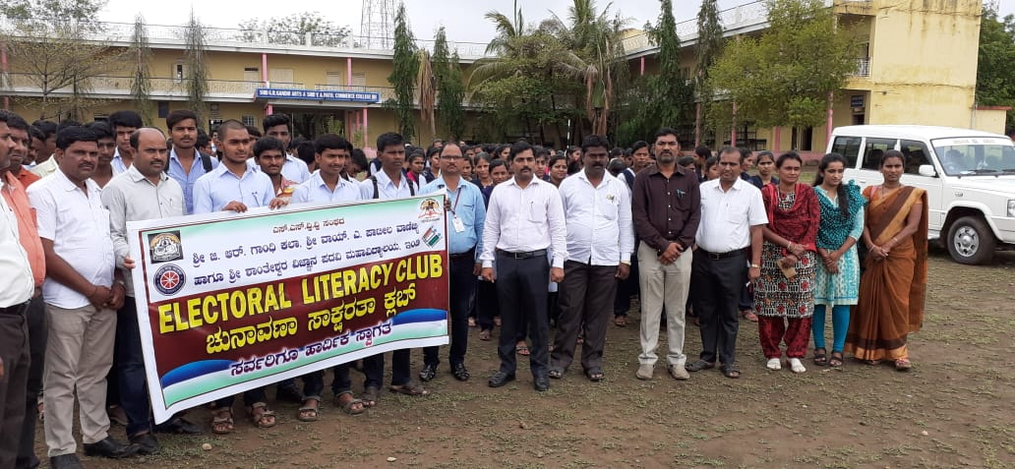

KANNADA JANAPADA VICHARA SANKIRNA HELD ON 18-09-2019 GUEST DR.M S MAGANGERI AND B N PATIL
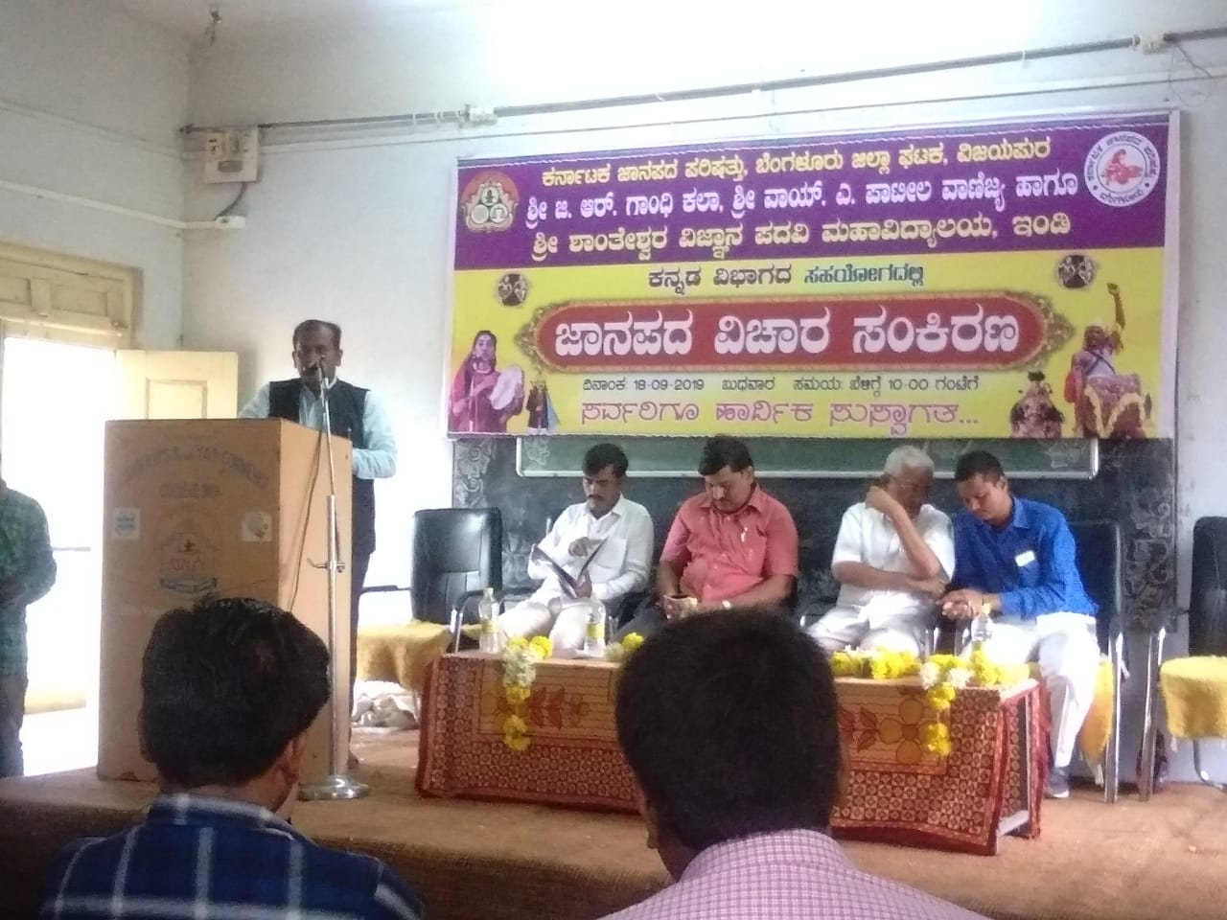
NSS 50 YEAR CELEBRATION PROGRAMME GUEST A MUJUGOUNDU DEPARTMENT OF FOREST
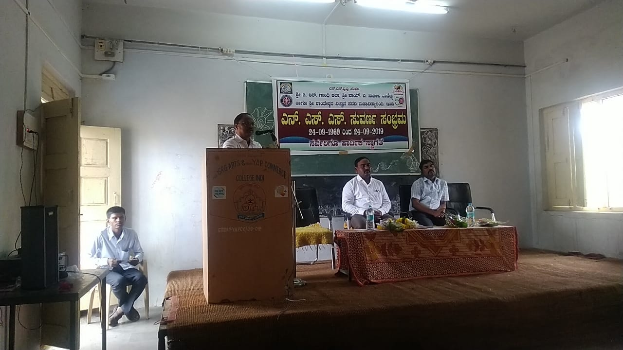

SRI G R GANDHI AND SRI Y A PATIL COMMERCE AND SHRI SHNATHESHWAR SCIENCE DEGREE COLLEGE CELEBRATING THE GANDHI JAYANTHI AND LALBHAUDAR SHASHTRI JAYANTHI ON 02-09-2019
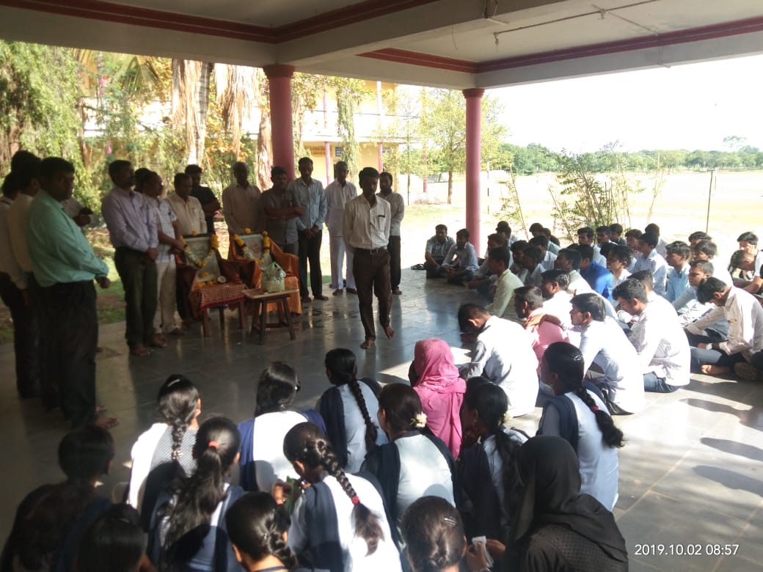

ONEDAY NATIONAL LEVEL WORKSHOP ORGANIZED BY THE DEPARTMENT OF ENGLISH HELD ON 04-10-2019
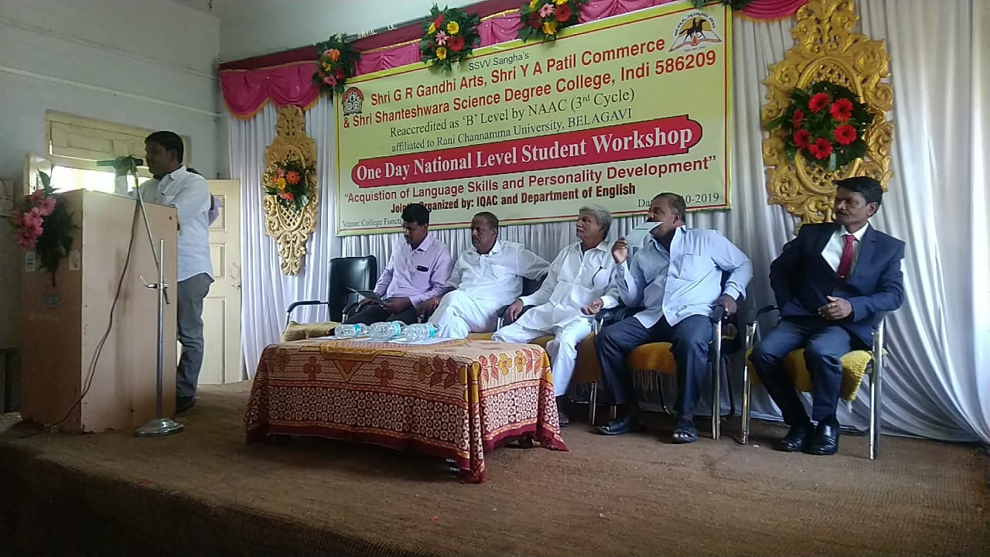

ONE DAY SPECIAL LECTURE ORGANISED BY DEPARTMENT OF SOCIOLOGY THE RESOURCE PERSON BY DR.SUDNYANI.S. BIRADAR.

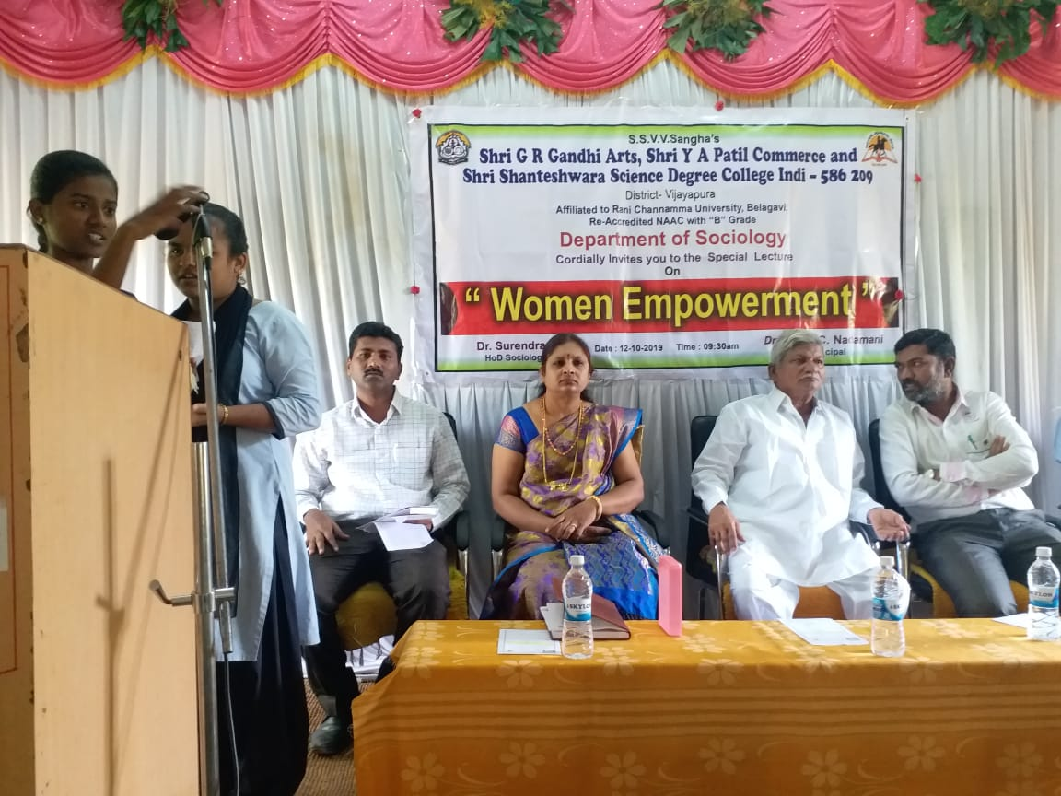
VISHWAMANAAVA DAY (KUVEMPU) CELEBRATION ORGANISED BY THE DEPARTMENT OF KANNADA HELD ON 01-01-2020. PRESIDED BY PRINCIPAL
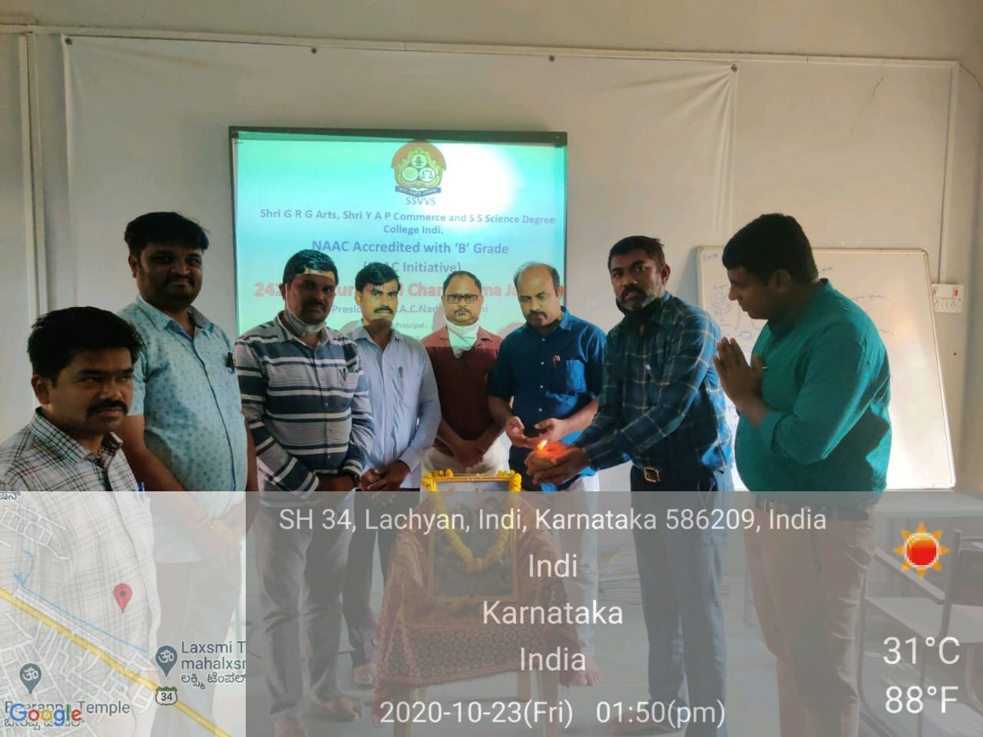

IN OUR COLLEGE CELEBRATION HAPPY NEW YEAR 01-01-2020 PRISEDED BY ALL THE STUDENTS AND THE FACULTY MEMBERS
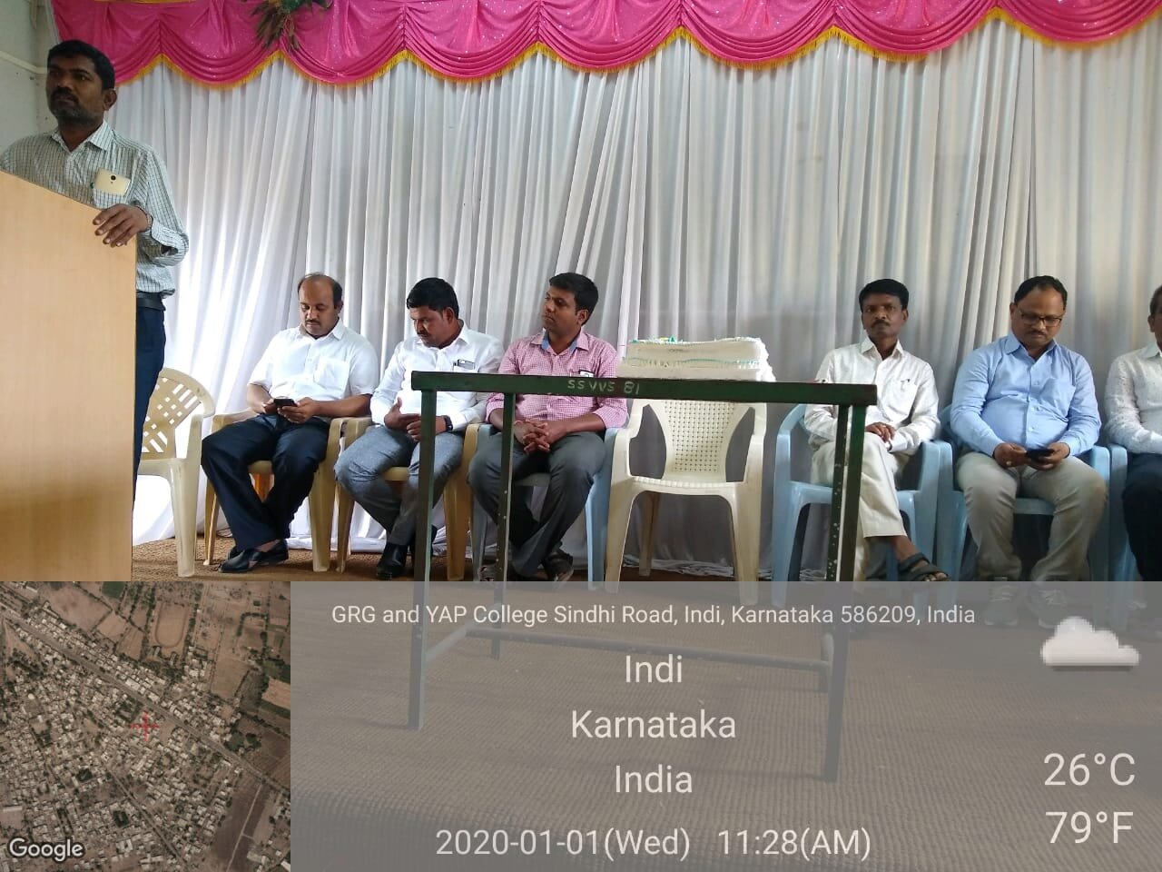
IQAC AND DEPARTMENT OF BACKWARD MINORITY GOVT OF KARNATAKA ORGANIZED 3 DAYS WORKSHOP ON 03-01-2020 FOR IAS AND KAS COACHING FOR THE STUDENTS GUEST BY VASANTH RATHOD BEO OF INDI TALUK, BCM OFFICER KOUL
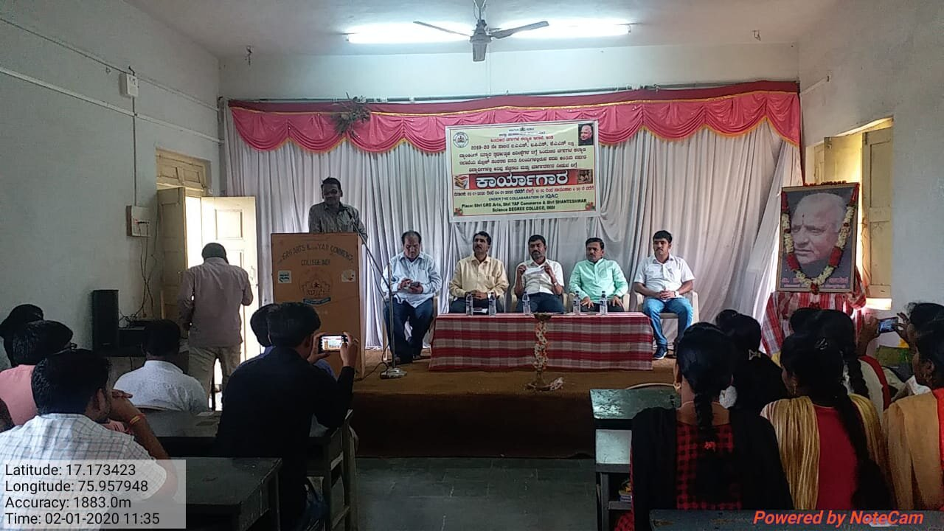

IN OUR COLLEGE CELEBRATION HAPPY NEW YEAR 01-01-2020 PRISEDED BY ALL THE STUDENTS AND THE FACULTY MEMBERS
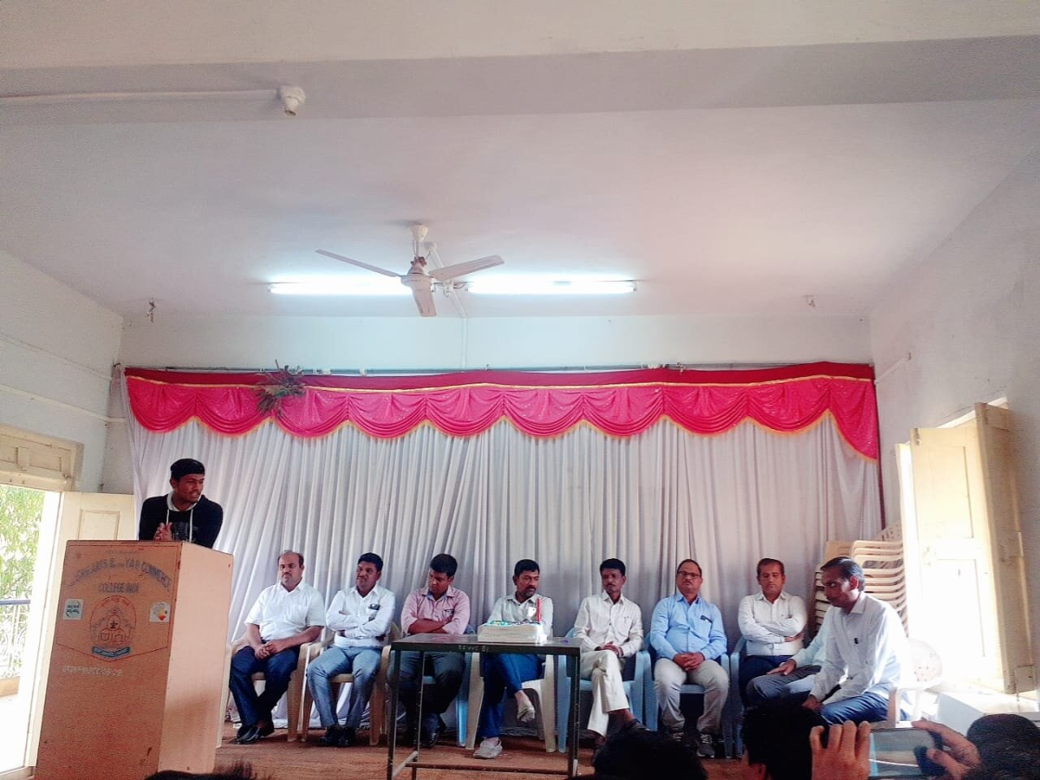
IN OUR COLLEGE TODAY CONDUCTING THE AWARENESS PROGRAMME ON THE ENROLLING THE NAMES IN VOTERS LIST FOR STUDENTS AND COMMON PUBLIC UNDER THE COLLABORATION OF TALUK OFFICE (THASILDAR) HELD ON 06-01-2020.
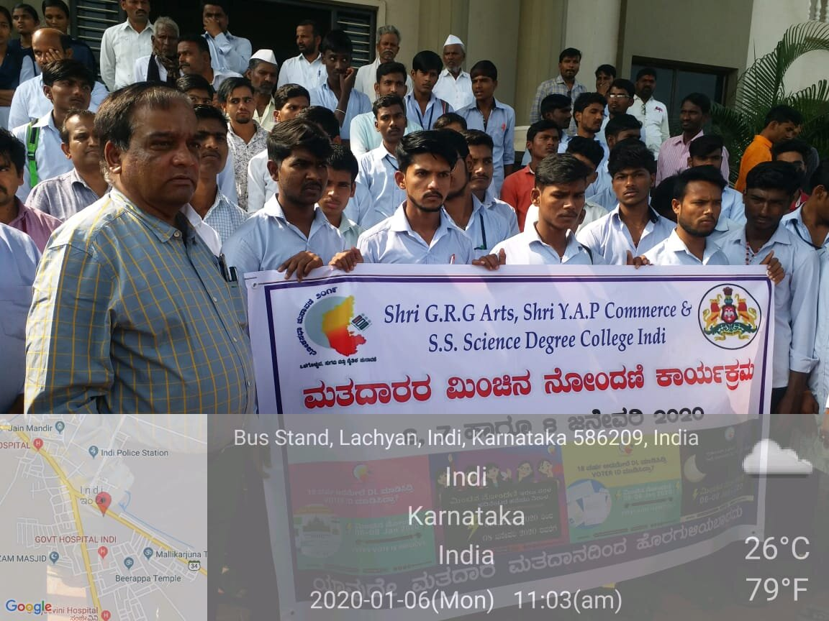

IN OUR COLLEGE CELEBRATED THE SWAMY VIVEKANADA JAYANTHI HELD ON 13-01-2020.
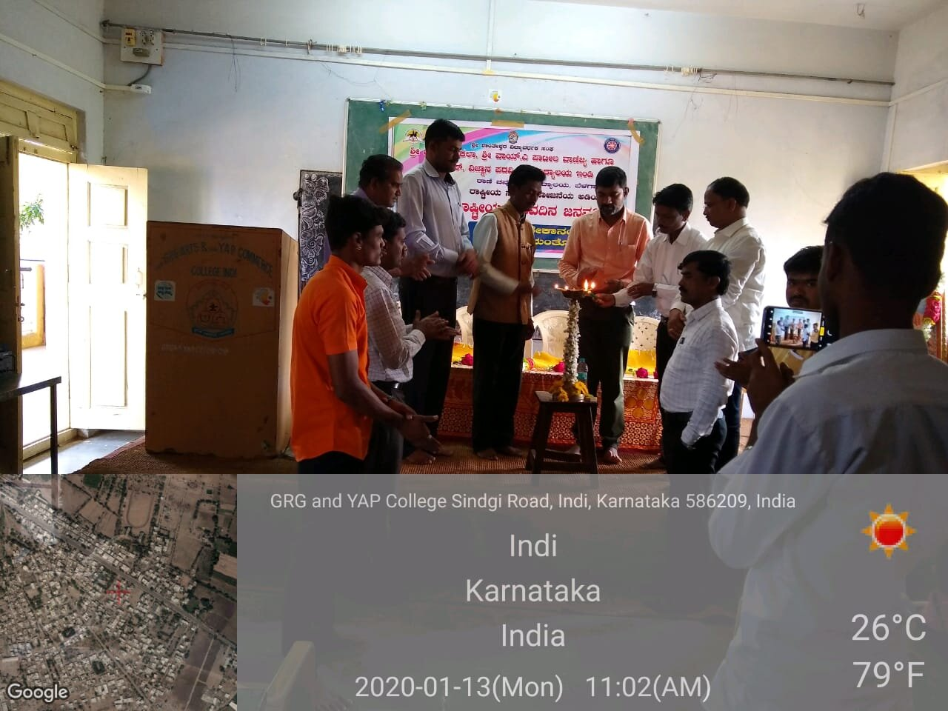
IN OUR COLLEGE CELEBRATING THE 70TH REPUBLIC DAY HELD ON 26-01-2020
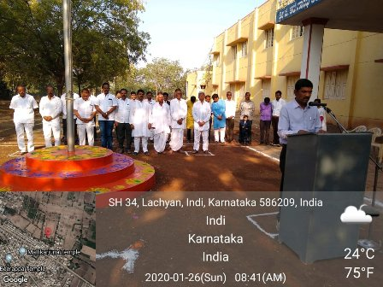

IN OUR COLLEGE AND PRIMARY AND TALUK HEALTH DEPARTMENT ORGANISED BY THE BLOOD DONATION CAMP HELD ON 28-02-2020
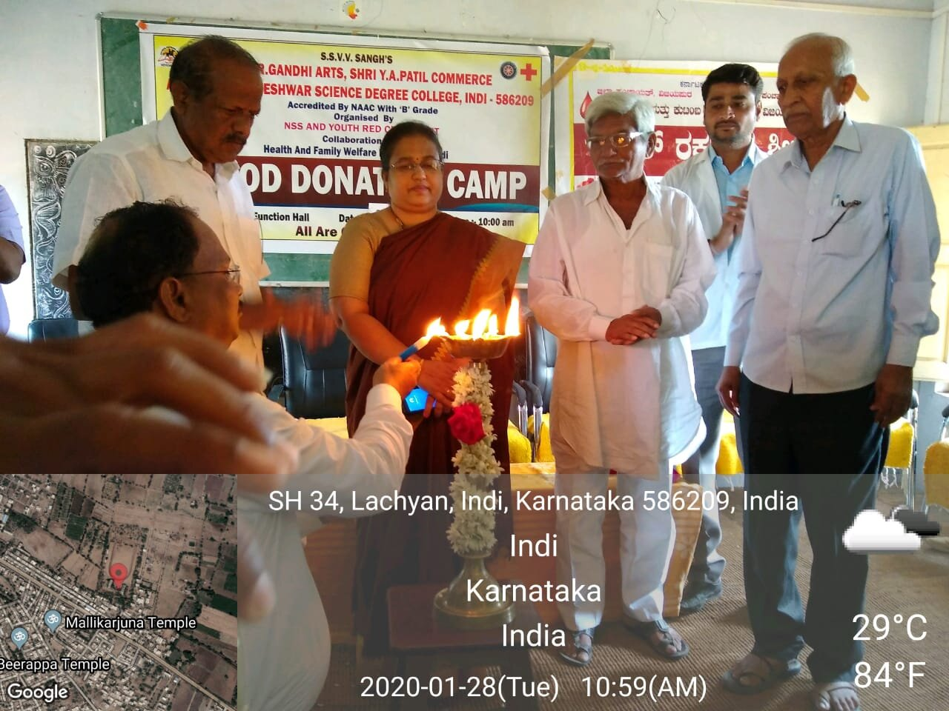

OUR COLLEGE STUDENT SRI SAADAM FIRST YEAR STUDENT WON THE SECOND PLACE IN KARATE CHAMPION IN NATIONAL AND INTERNATIONAL FEST.
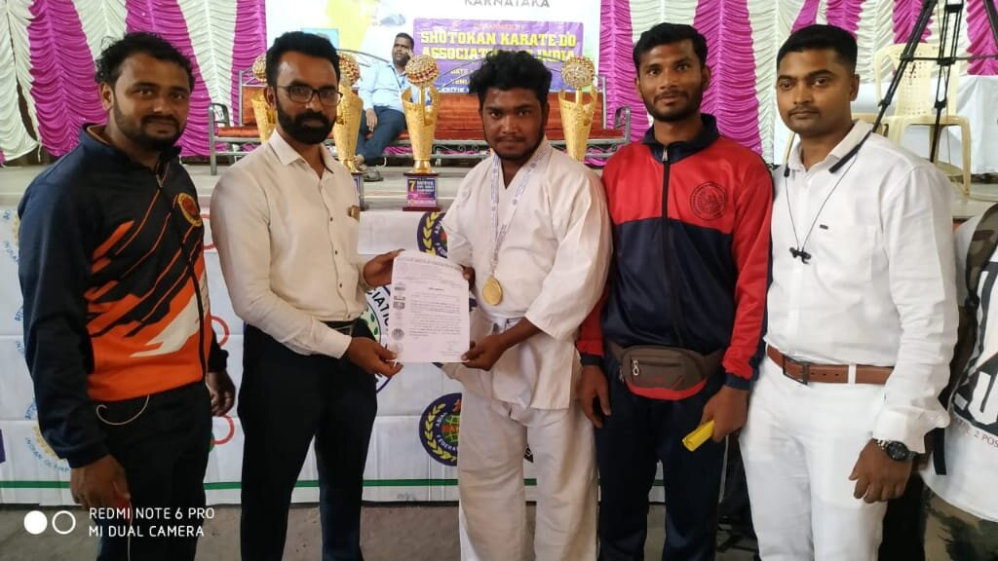

IN OUR COLLEGE THE EXAMINATION PURPOSE EACH STUDENTS WE ARE CHECK THE TEMPERATURE AND MASK IN COLLEGE PREMISES
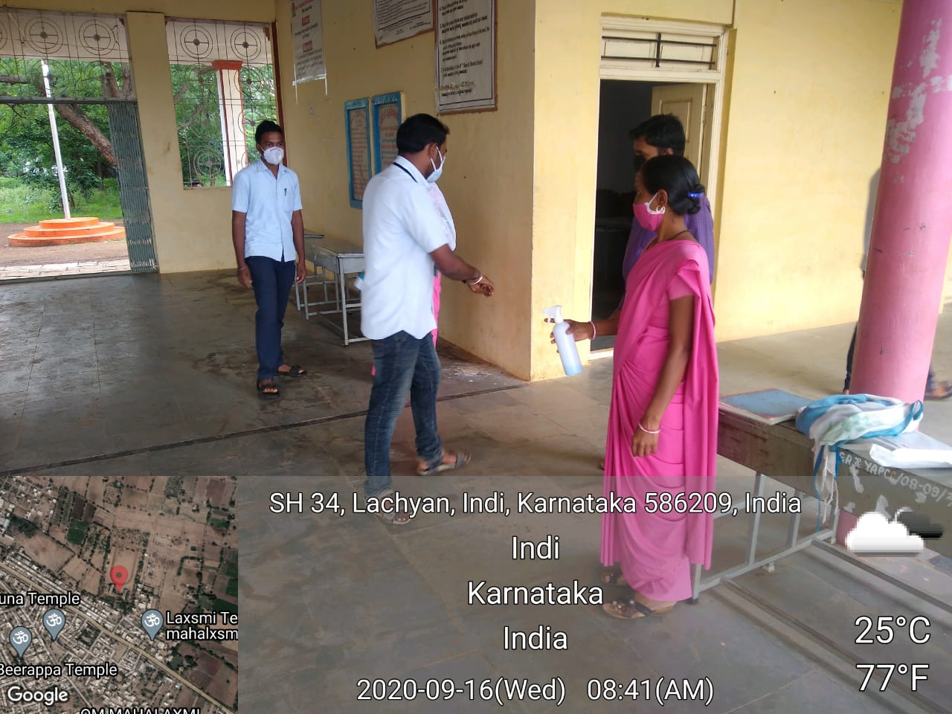

IN OUR COLLEGE PREMISES CONDUCT THE FIT INDIA FIT RUN ON 02-10-2020
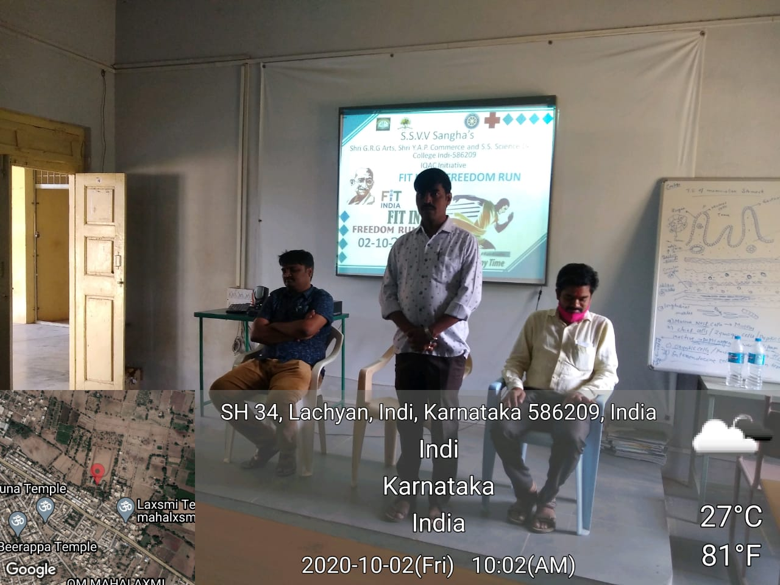

IN OUR COLLEGE CONDUCTING THE NATIONAL NSS DAY ON 24-09-2020
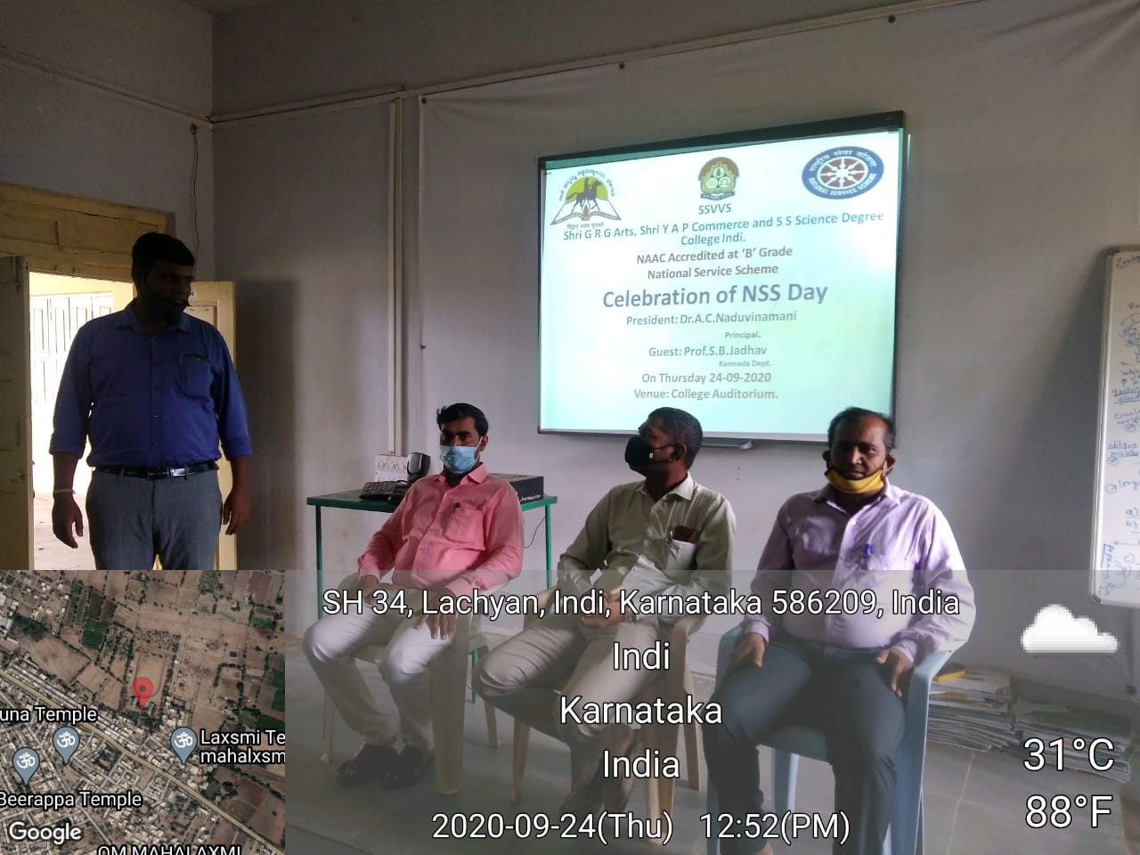

IN OUR COLLEGE CONDUCT THE NATIONAL YOGA DAY ON 22-06-2020
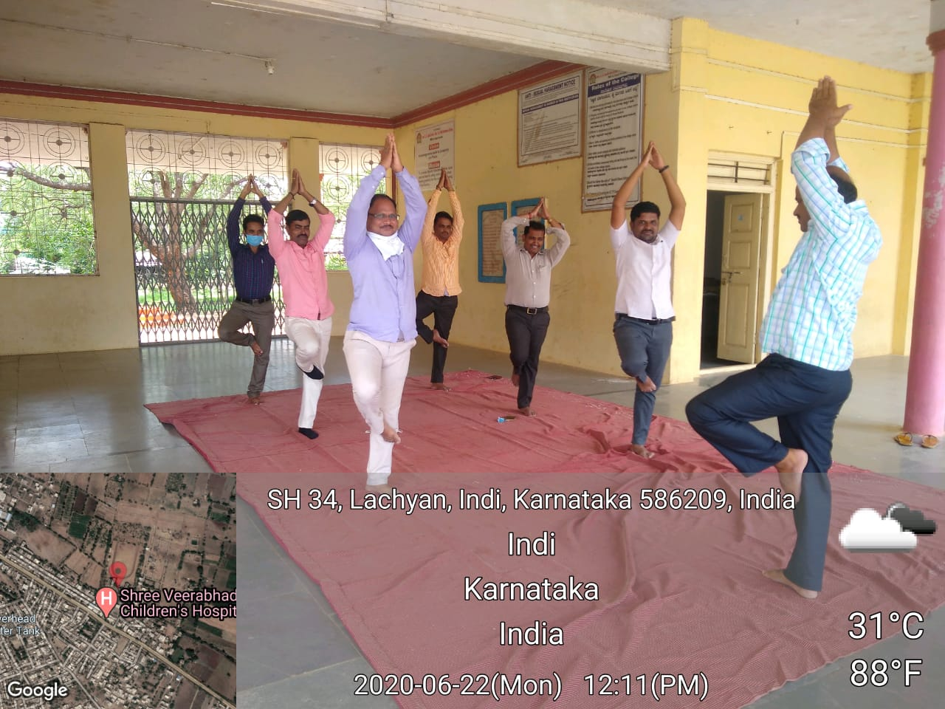

IN OUR COLLEGE CELEBERATE THE TEACHERS DAY PROGRAMME ON 05-09-2020
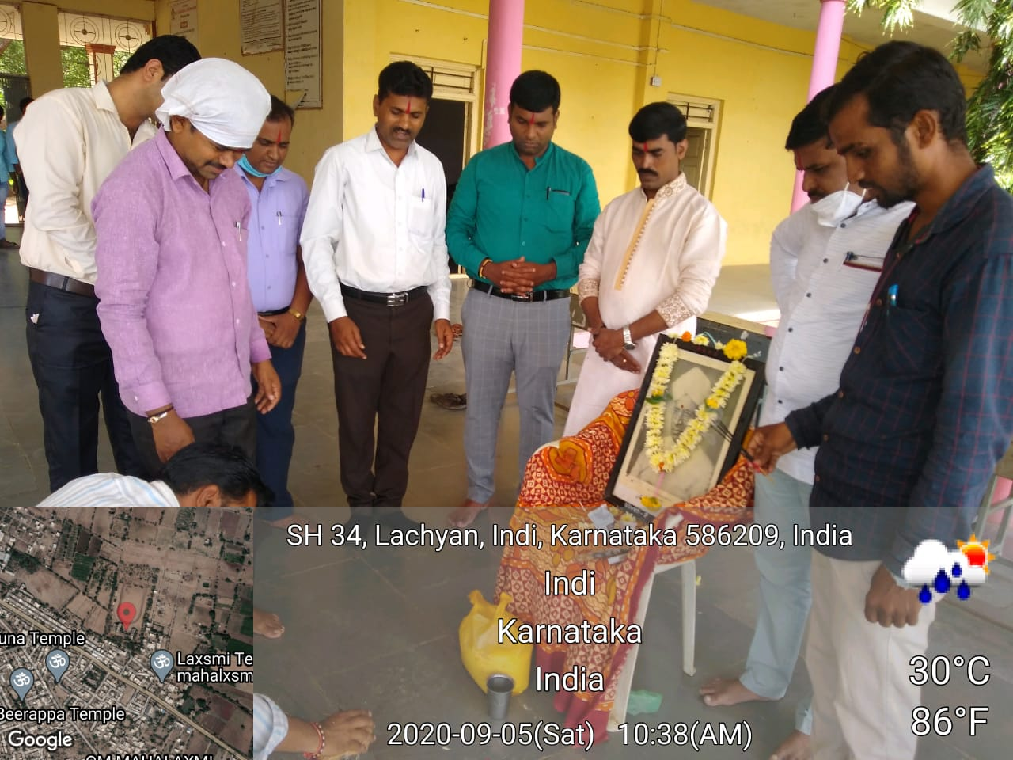

IN OUR COLLEGE 21-05-2020 CONDUCTING THE ANTI-TERRORISM DAY IN COLLEGE PREMISES
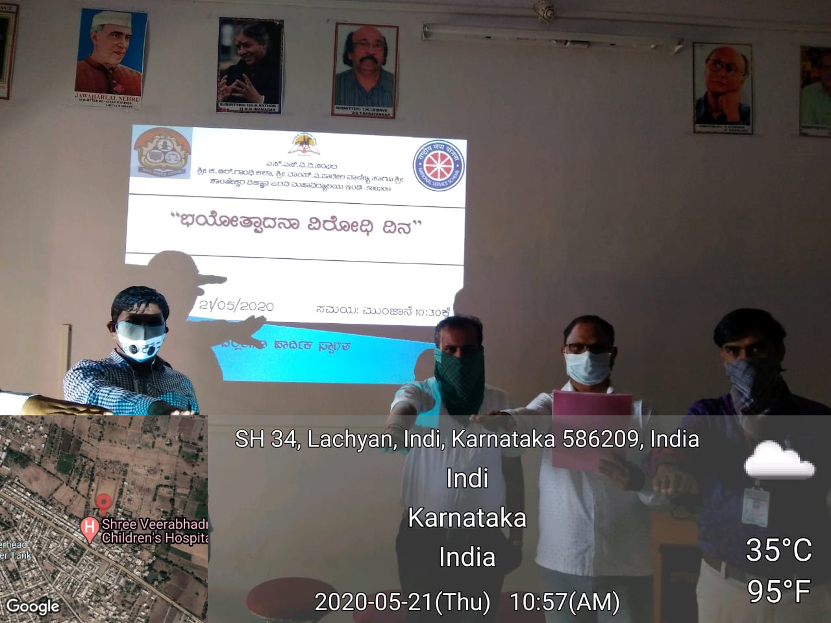

IN OUR COLLEGE 24-09-2020 CONDUCTING THE HINDI DIWAS.

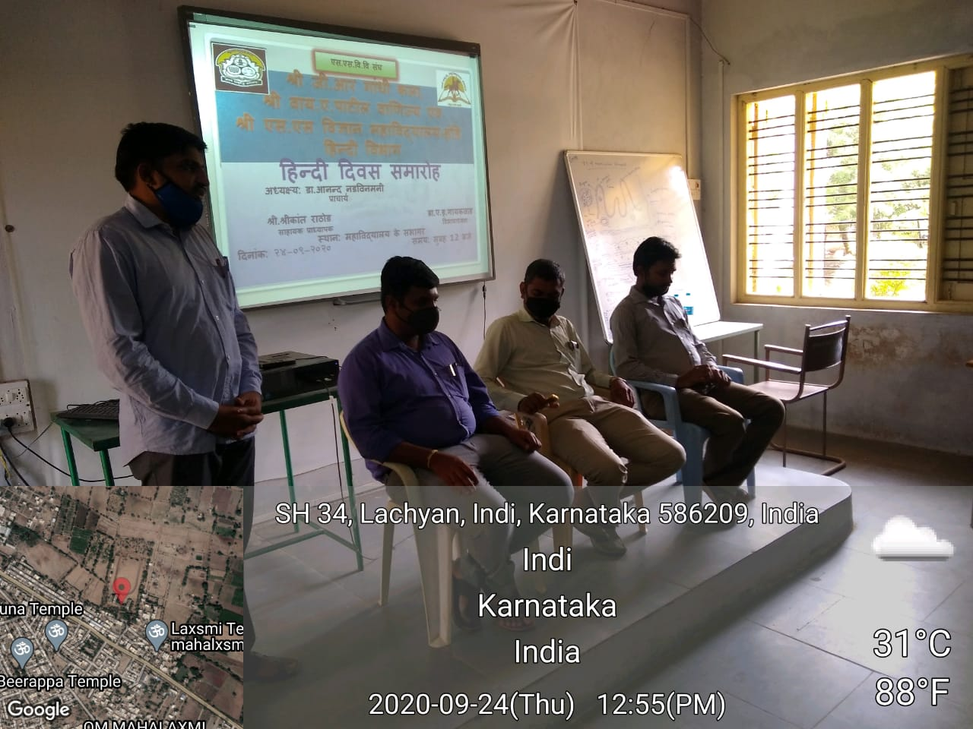

IN OUR COLLGE 26-06-2020 CONDUCTING THE INATERNATIONAL DAY AGAINST ABUSE DAY.
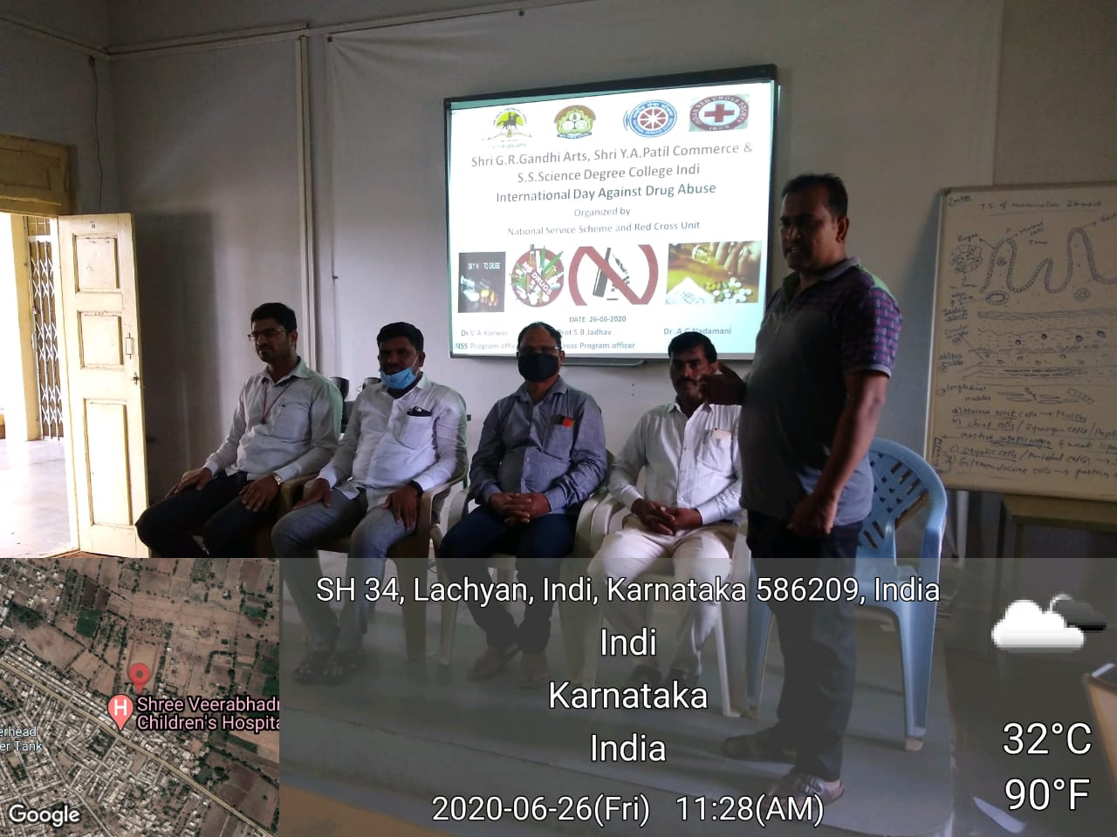

IN OUR COLLEGE 02-10-2020 CELEBERATING THE GANDHI JAYANTHI AND LALBHAUDAR SHASTRI JAYNTHI.
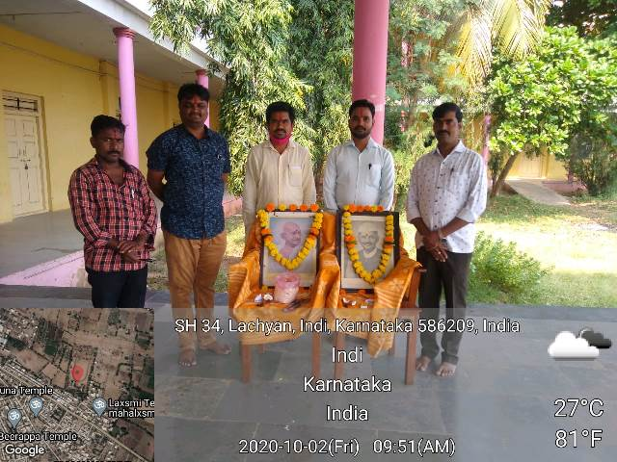
IN THE DURATION OF EXAMINATION CORPORATION EMPLOYEES SANITIZE BY THE COLLEGE BUILDING ON 15-09-2020
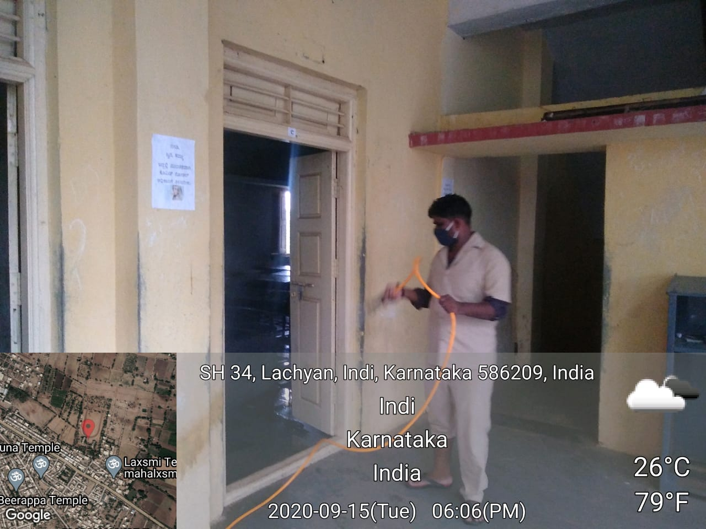

IN OUR COLLEGE 23-10-2020 WE ARE CELEBRATING THE 242ND KITTUR RANICHANNAMMA JAYANTHI
NATIONAL ONLINE ENGLISH WEBINAR
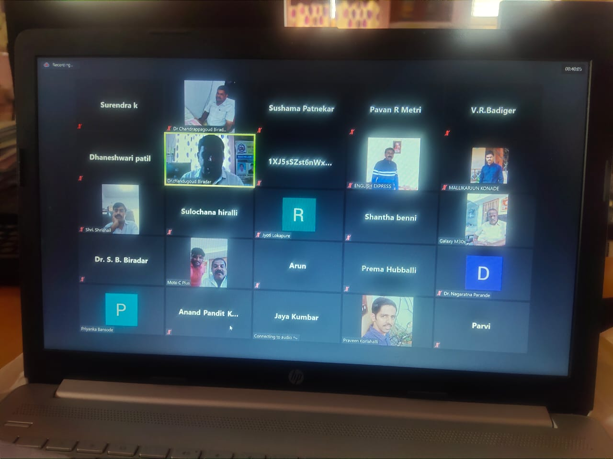

NATIONAL ONLINE ENGLISH WEBINAR

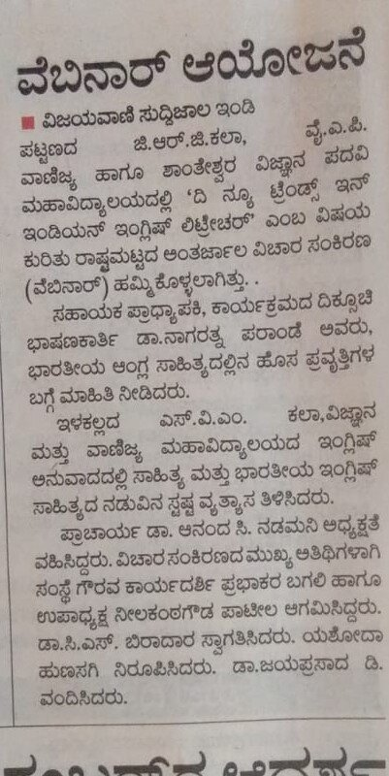
IN OUR COLLEGE 27-10-2020 WE ARE ORGANIZING THE VIGILIANCE AWARENESS WEEK THROGUH NSS AND YOUTH REDCROSS
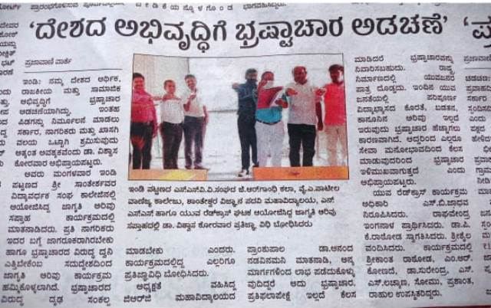

CELEBRATED THE VALMIKI JAYANTI ON 31-OCT-2020

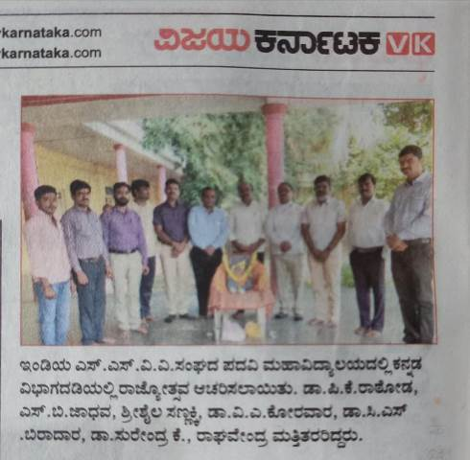

NATIONAL UNITY DAY UNDER NSS ON 31- OCT-2020
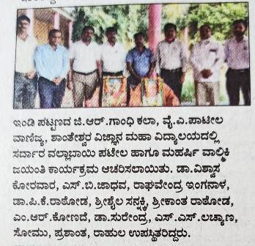

CELEBRATED KANNADA RAJYOSTAVA ON 01-NOVEMBER- 2020
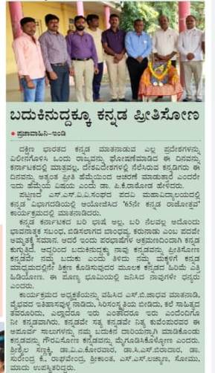
IN OUR COLLEGE 11-11-2020 CLEBERATING THE INDIAN EDUCATION DAY
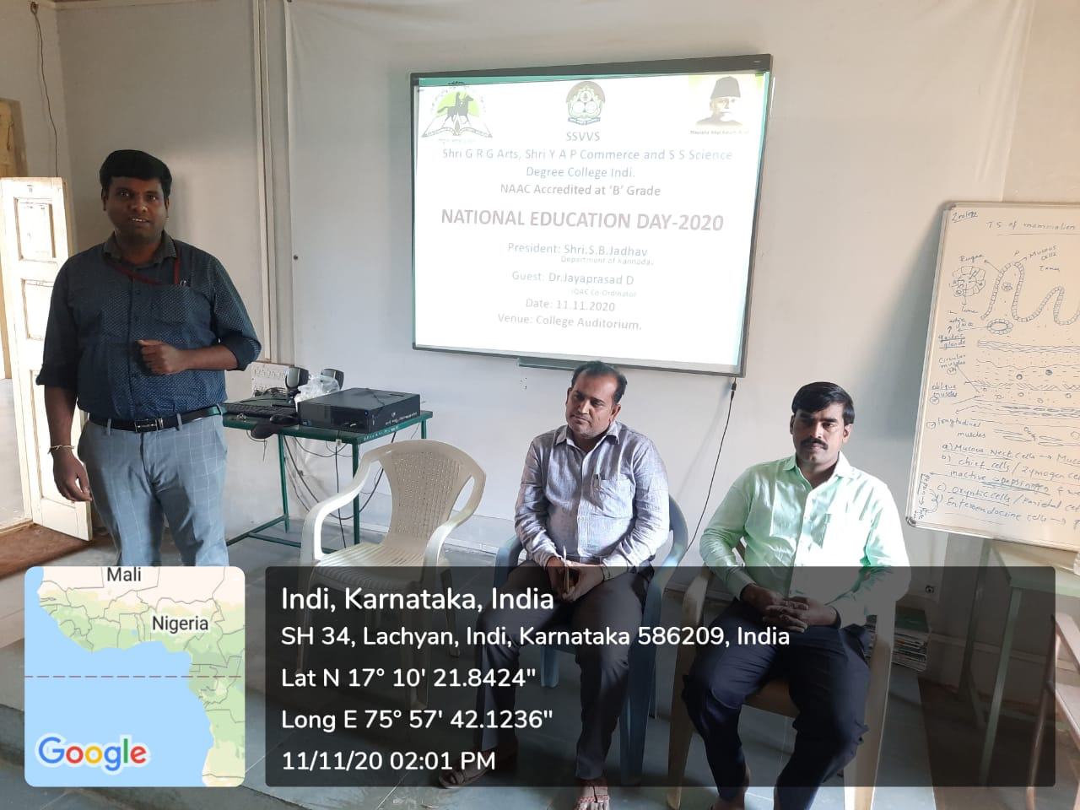

IN OUR COLLEGE 11-11-2020 CLEBERATING THE INDIAN EDUCATION DAY

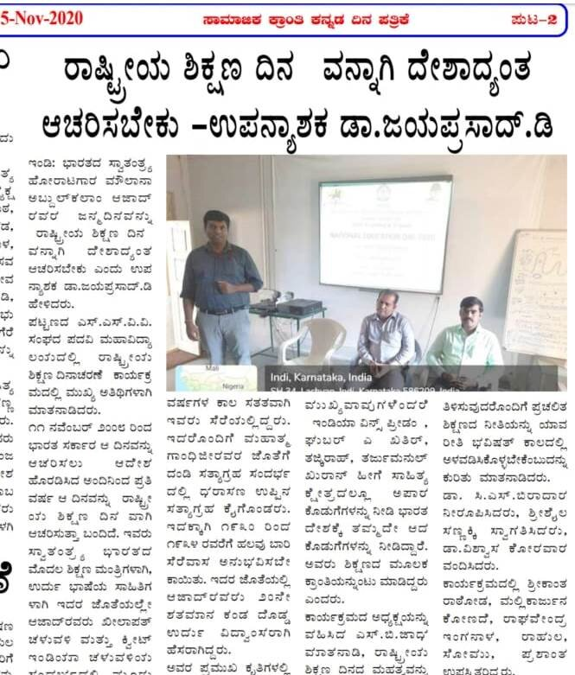
IN OUR COLLEGE 26-11-2020 CELEBERATING THE INDIAN CONSTITUTIONAL DAY
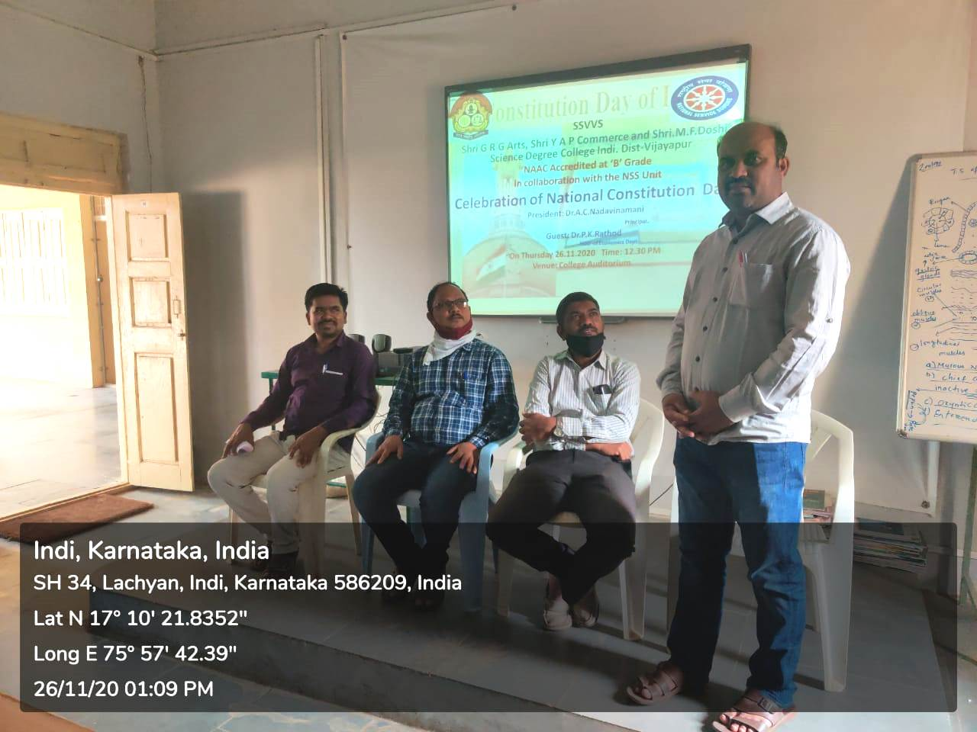

IN OUR COLLEGE 20-11-2020 ORGANISING THE ONS DAY STATE LEVEL KANNADA WEBINAR
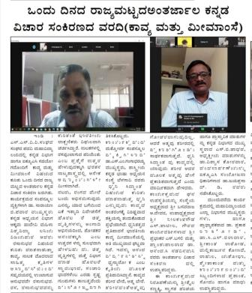
IN OUR COLLEGE CONDUCTION ONE DAY NATIONAL WEBINAR ON 28-11-2020. ORGANISED BY THE DEPARTMENT OF COMMERCE AND ECONOMICS
